Supplementary materials

Genomic and transcriptome analyses of a thermophilic bacterium Geobacillus stearothermophilus B5 isolated from compost reveal its enzymatic basis for lignocellulose degradation
Mengmeng WANG, Jiaxi MIAO, Xuanqing WANG, Tuo LI, Han ZHU, Dongyang LIU*, Qirong SHEN
Jiangsu Provincial Key Lab of Solid Organic Waste Utilization, Jiangsu Collaborative Innovation Center of Solid Organic Wastes, Educational Ministry Engineering Center of Resource-saving fertilizers, Nanjing Agricultural University, Nanjing 210095, Jiangsu, People’s Republic of China
Running title: Genomic information analysis of a lignocellulose degrading strain B5 isolated from composting
Email addresses:
Mengmeng Wang: 2013203040@njau.edu.cn
Jiaxi Miao: 2017203039@njau.edu.cn
Xuanqing Wang: 2017203031@njau.edu.cn
Tuo Li: 2018203039@njau.edu.cn
Han Zhu: 2018103120@njau.edu.cn
Dongyang Liu: liudongyang@njau.edu.cn
Qirong Shen: shenqirong@njau.edu.com

Supplementary Figure Legends
Fig S1. Colony morphology and microscopic observation of the B5 strain;
Fig S2. Phylogenetic tree based on the alignment of the recN gene sequence of strain B5;
Fig S3. The utilization of different carbon sources of G. stearothermophilus B5;
Fig S4. Gene count distributions of carbohydrate-active enzyme (CAZy) families of G. stearothermophilus B5.

Fig. S1

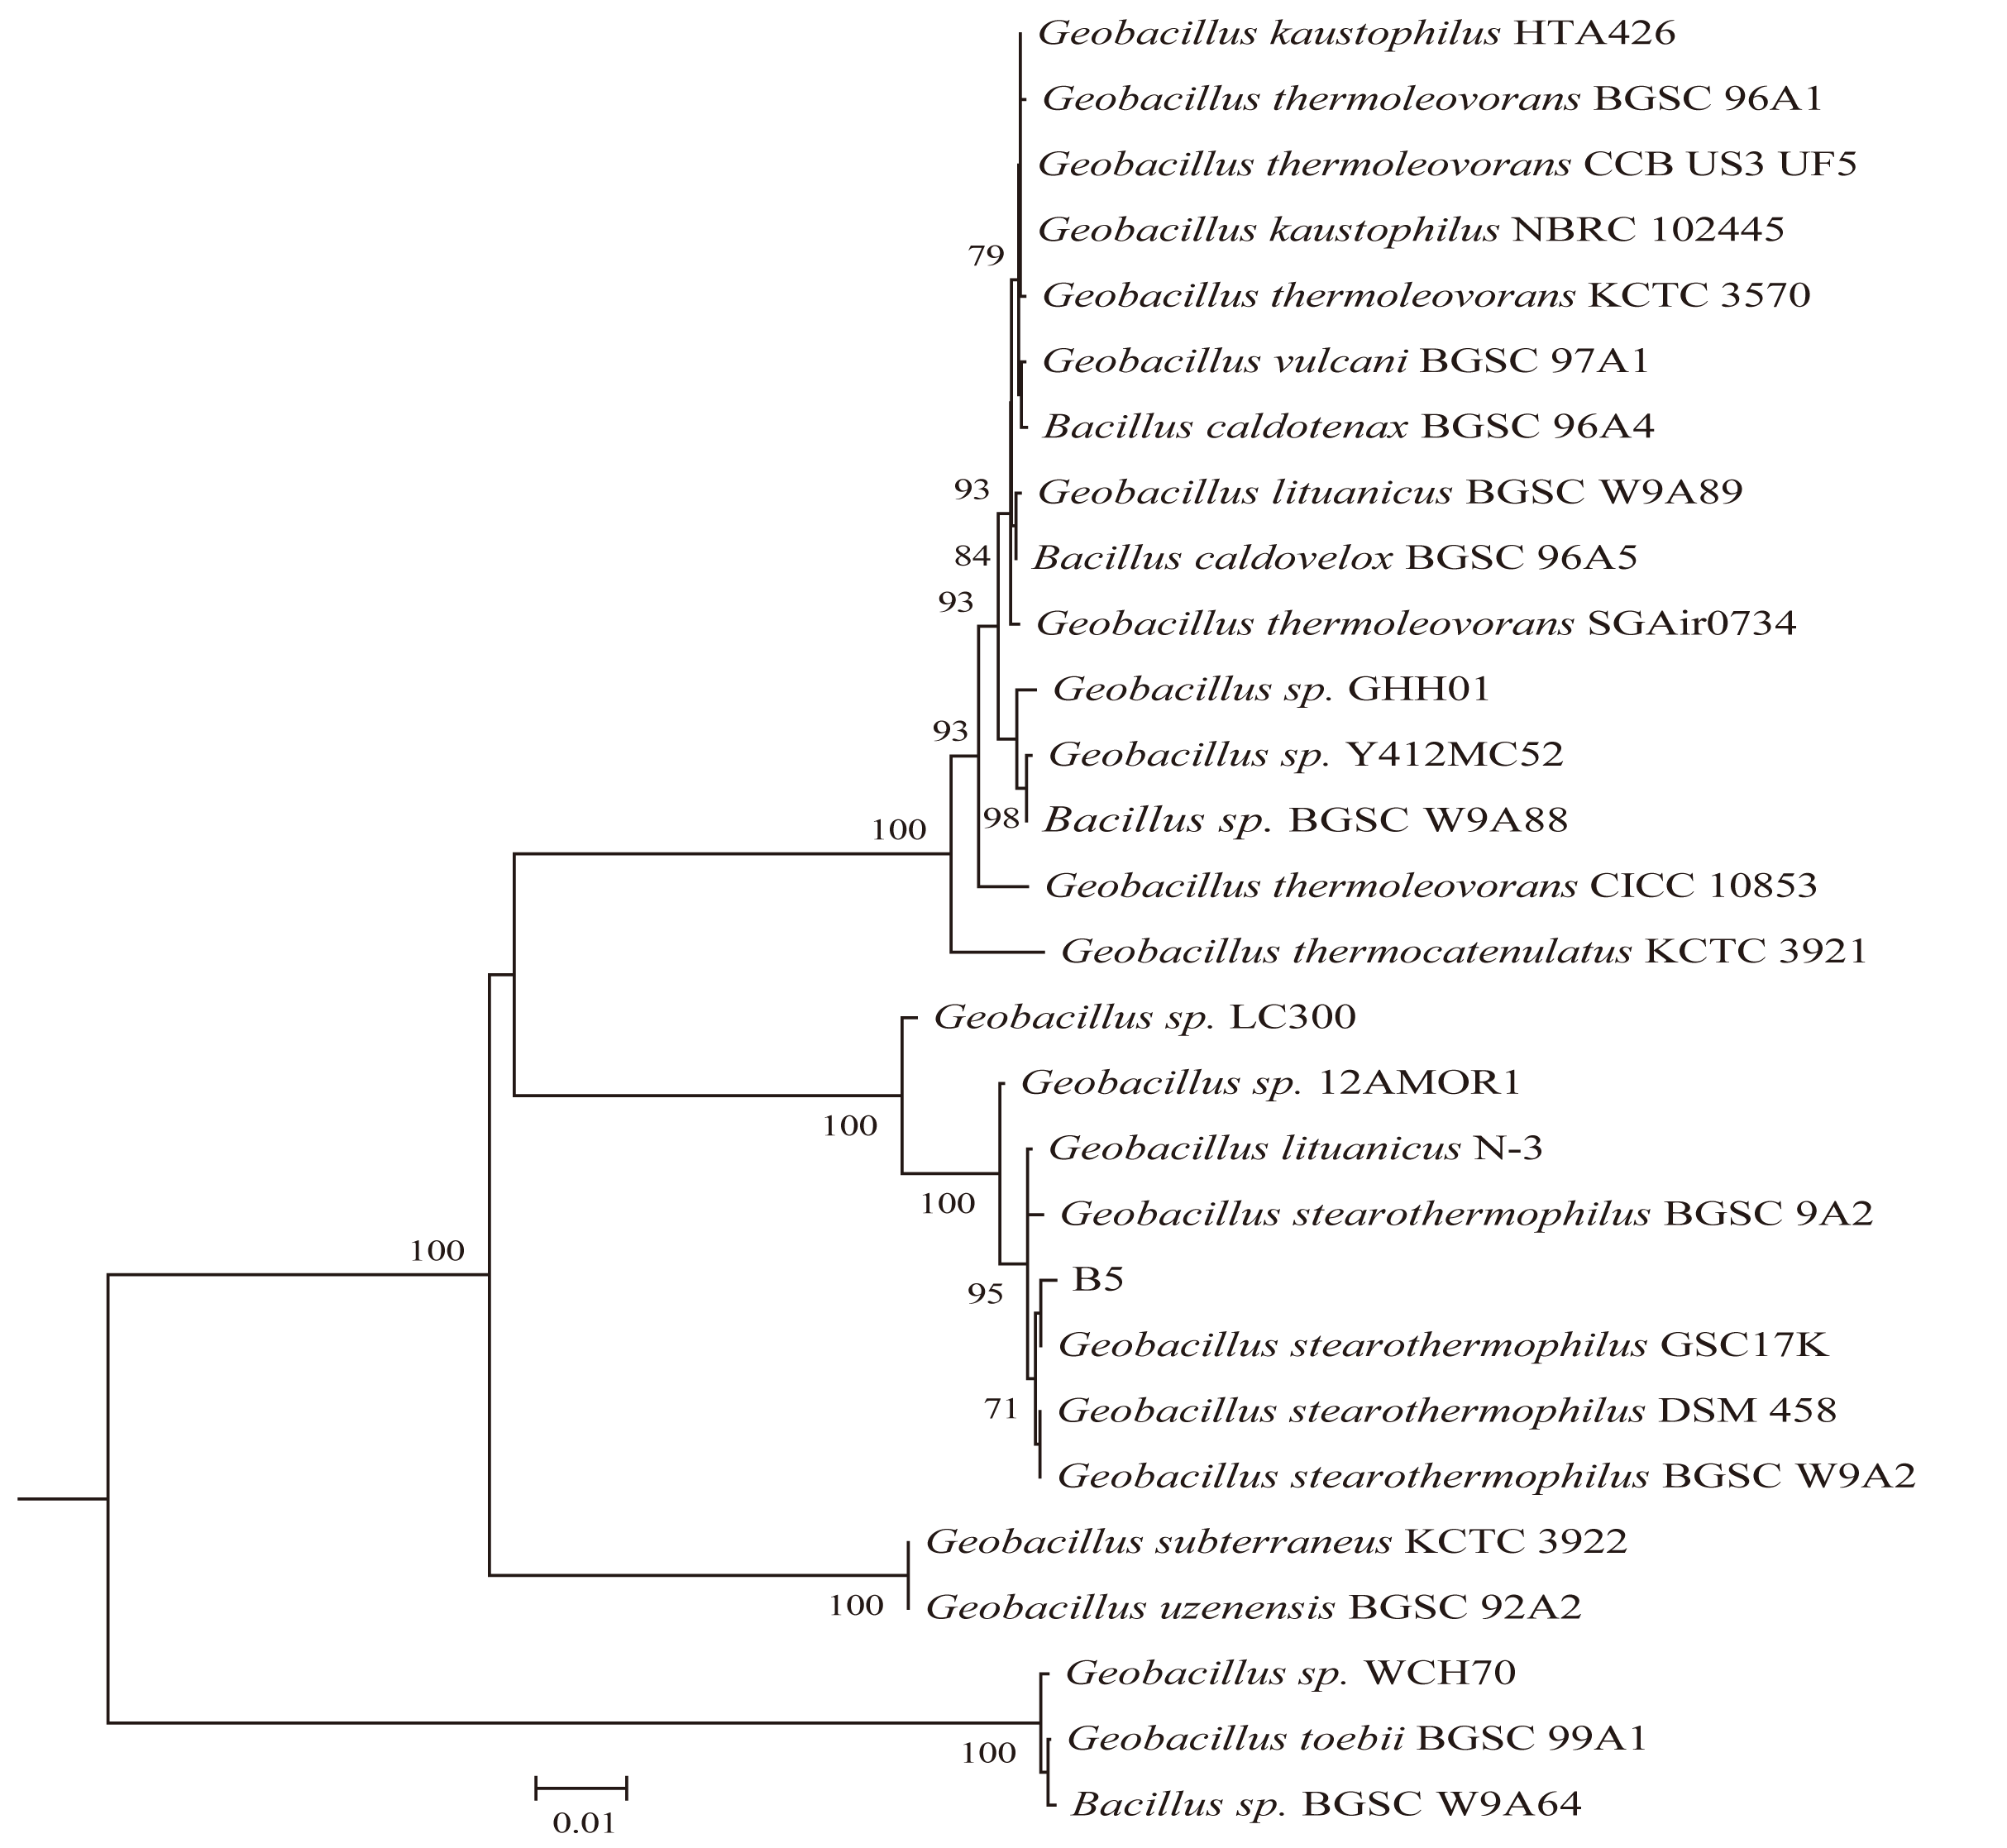 Fig. S2

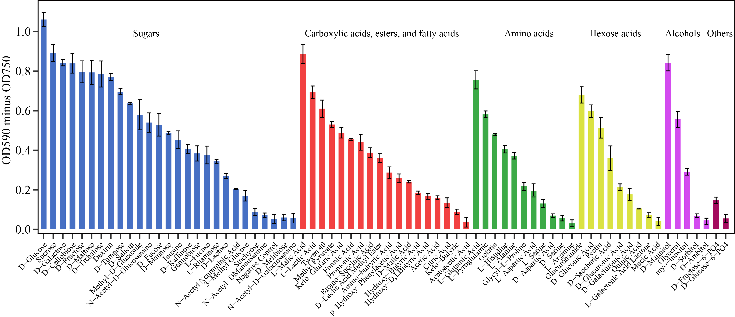
Fig. S3

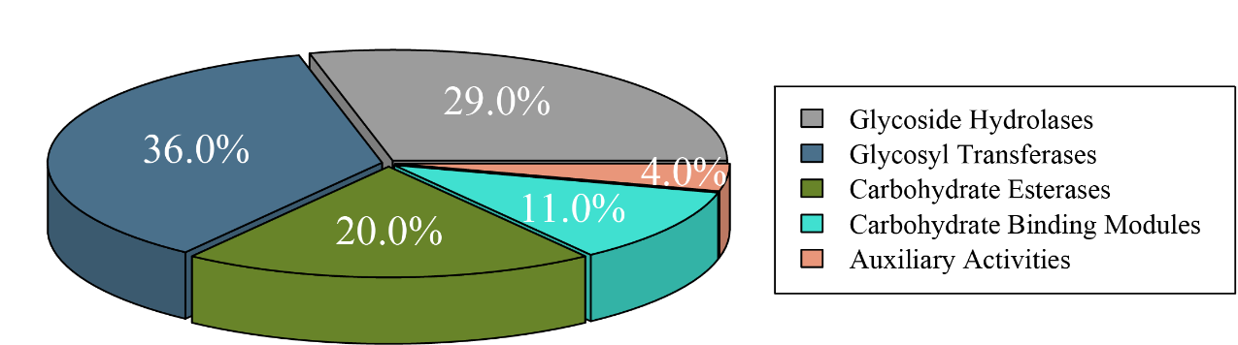
Fig. S4

* To whom correspondence should be addressed: liudongyang@njau.edu.cn; Tel: +86 25 84396853; Fax: +86 25 84395212, College of Resources and Environmental Science, Nanjing Agricultural University, Nanjing, CHINA.

